|  |
| --- |
| Team bmp |
| Time Warrior |
| A game where you go through time, mess time up and put it all back together. *tent. title |
|  |
| **Alex Beerman, Jared Bills, Matthew Morrill, John Parks** |
| **2/8/2011** |

Updated:

V.01 2/8/11

V.02 2/20/11

V.03 2/26/11

V.05 2/28/11

V.50 4/12/11

|  |
| --- |
| This document is a GDD for the Senior Project team BMP. Copyright 2011. Full GDD can be found by scrolling down. |

Table of Contents

Overview 4

Premise 4

Introduction 4

Genre 4

Target Demographic 4

Technical Specifications 4

Platforms 4

File Formats 4

API’s 4

Code Language 4

Game Mechanics 4

Core Functionality 5

Data Files 5

Resource Loading and Unloading 5

Game Play 5

Game Initialization 7

Game Elements 7

RPG Elements 7

Enemies 7

Weapons 8

Magic 8

Levels 9

Medieval Era 9

Arthurian/European 10

Pirates 10

Far East/Asian 10

Modern Era 10

Enemies 10

Distinct Player Characteristics 11

Post-Apocalyptic 11

Enemies 11

Distinct Player Characteristics 11

Hub World 11

Enemies 11

Distinct Player Characteristics 11

Story 11

Main Story 11

Countries 12

Overview

## Premise

Travel through the ages to gain redemption, and "freedom". Fight, explore, loot, and level  
by yourself or up to 3 friends.

## Introduction

You are a prisoner for an unknown crime. Your freedom can be gained by going through the ages and liberate the demons infecting time. You are armed with a gauntlet that can transfer energy from the universe and creatures into “magic”. You’re goal is to get to your freedom.

## Genre

Action Role-Playing Game

## Target Demographic

T for Teen

## Technical Specifications

Processor: Intel Core 2 Duo 2.2 GHz

RAM: 2 GB

OS: Windows XP SP 3 or Windows 7

Hard Drive: 115 MB

Video Card: Intel 965 Chipset Mobile

### Platforms

PC

### File Formats

.txt, .tbmp, .bmp

### API’s

SDL

### Code Language

C++

# Game Mechanics

The main mechanics of the game include the gauntlet, which creates the magic and weapons. The gauntlet has memory storage, which acts as the inventory system, which allows the player to switch their magic, weapons, and armor on the fly, using chips that contain the data.

## Core Functionality

### Data Files

All data files are stored in .bmp’s, or .txt’s.

### Resource Loading and Unloading

Resource Loading and Unloading is done as the game runs, loading from .txt files and .bmp files. Saving to files will require another .txt per client.

## Game Play

The game play uses a top-down camera for ease of use and navigation. Since there would be no reason in which to rotate the camera, there doesn’t need to be a camera rotation. The controls of the game would be a keyboard and mouse, and remappable. The default keys are as shown:

|  |  |
| --- | --- |
| Default Key | What it would be used for: |
| W | Move up |
| A | Move left |
| S | Move down |
| D | Move right |
| Left Click | Activate whatever attack (magic or weapon) is configured as 1st attack |
| Right Click | Activate whatever attack (magic or weapon) is configured as 2nd attack |
| I | Open up the Inventory |
| H | Use Health Potion |
| E | Use Energy potion |
| 1-3, 5-7 | Quickly change left-click attack (1-3) or right-click attack (5-7) to another attack of the same type (i.e. change Basic Fire to Advanced or Expert Fire). |
| Space Bar | Activate an NPC’s Dialogue when in range |

HUD design:

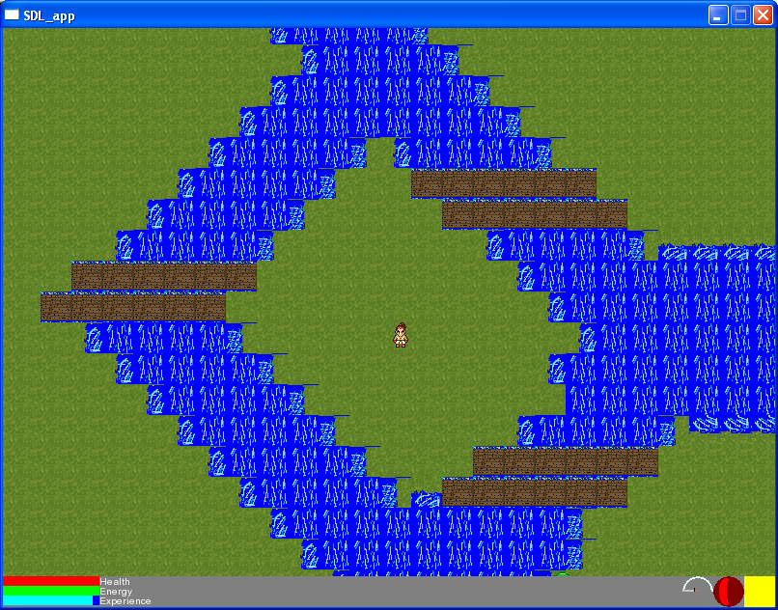

* Health, energy, and experience bars in lower-left corner
* Stat button, in lower-right corner, opens a menu to show player’s stats when clicked
* Icons for attacks set as ATK1 and ATK2 in lower-right corner, near stat button

Experience System:

The player’s experience requirement for each level is calculated as:

Experience requirement = “current level” + “experience requirement from previous level”

|  |  |
| --- | --- |
| Level | XP Needed |
| 1 | 2 |
| 2 | 4 |
| 3 | 7 |
| 4 | 11 |
| 5 | 16 |

Upon leveling up, the player can choose to boost either their Strength or Intellect, which affects their other stats:

|  |  |  |
| --- | --- | --- |
| Stat | Description | Relation to Other Stats |
| Health | Life points | Increases with Strength |
| Energy | Used to handle cost of attacking | Increases with Intellect |
| Strength | Increases damage with Weapons | Increases Health and Defense |
| Intellect | Increases damage with Magic | Increases Energy and Resistances |
| Defense | Used in combat with Weapons | Increases with Strength |
| Fire Resistance | Used in combat with Fire Magic | Increases with Intellect |
| Ice Resistance | Used in combat with Ice Magic | Increases with Intellect |
| Lightning Resistance | Used in combat with Lightning Magic | Increases with Intellect |

### Game Initialization

Initializes with only one player, at which point the Hub world loads. No monsters are present in the Hub World, but monsters are loaded dynamically once the player steps into the Portal.

## Game Elements

Magic is categorized by its element, which can be Divine, Fire, Ice, or Lightning. Each element has 3 levels of spells: Basic, Advanced, and Expert. When applied to the same target, spells can combine to create combinations.

### RPG Elements

An Inventory system will be implemented that WILL NOT pause the game. Players can switch whatever chips they currently have equipped with another chip whenever they want. However, they can still be attacked, and can still move. Each enemy defeated gives a certain amount of character exp, and each use of a chip gives a small amount of Chip exp. Each character level gives one chip level for the player to use as they wish, which helps them specialize in a certain element or weapon type. Extra chips, which can be found after the enemies are killed on the ground, can be sold for a certain amount of chip exp, depending on the chip sold, which can be applied to any chip chosen by the player.

### Enemies

Each enemy gives the player a certain amount of experience, based on their relative levels:

Total experienced earned = “enemy level” * (“enemy level” / “player level”)

All enemies are strong and weak against a certain type of magic, depending on what they are categorized as (made of, covered in, or attributed as such):

|  |  |  |  |
| --- | --- | --- | --- |
| Material | Examples | Strong Against | Weak Against |
| Wood | flora, plants, vegetation | Ice | Fire |
| Fire | fire, magma, lava | Lightning | Ice |
| Earth | Ground, dirt, mud, sand, rock | Lightning | Fire |
| Metal | metal, gold, silver | Ice | Lightning |
| Water | Water, ice, water-vapor, steam | Fire | Lightning |
| Air | Gases, wind, lightning | Ice | Fire |
| Rubber | Rubber, elastic | Lightning | Ice |
| Light | Light, heavenly, angelic, divine | Fire, Divine | Ice |
| Dark | Dark, undead, shadows | Ice | Fire, Divine |

More information can be found in each Level’s section titled Enemies.

### Weapons

There are four main weapon types, Slash-Pierce-Blunt-Range. Each weapon type also has 3 levels to it, getting more destructive as they go. Each weapon changes with the age dependent on what they are. For example a crossbow in the medieval era will change to a gun in the modern era. More information can be found in the Distinctive Player Characteristics section.

Total damage done with weapons is related to the player’s strength, increasing the weapon’s base damage by a certain percentage:

Total weapon damage = “base damage” * ((“base damage” + strength) / “base damage”)

When hit by weapons, total damage taken is decreased by a certain percentage using the defense stat:

Total damage taken = “total weapon dmg” * (“total weapon dmg”/ (“total weapon dmg” + defense))

Each weapon type has a distinctive use or effect:

|  |  |  |  |  |
| --- | --- | --- | --- | --- |
|  | Blunt | Range | Slash | Pierce |
| Effect | Knockback | Projectile | High damage | Chance to inflict extra damage |

Each category follows the pattern described above.

|  |  |  |  |
| --- | --- | --- | --- |
| Category | Basic | Advanced | Expert |
| Blunt | Blunt Bash | X-Bash | Hurricane Bash |
| Range | Ranged Shot | Double Shot | Tri-Shot |
| Slash | Slash Strike | X- Strike | Hurricane Strike |
| Pierce | Pierce Stab | Running Stab | Stabby-Stabby |

### Magic

Like weapons, total damage dealt with magic is related to one of the player’s stats. The player’s intellect is used to increase base magic damage by a certain percentage:

Total magic damage = “base damage” * ((“base damage” + intellect) / “base damage”)

When hit by magic, total damage taken is decreased by a certain percentage using the appropriate resistance, which accounts for fire, ice, or lightning damage:

Total damage taken = “total magic dmg” * (“total magic dmg”/ (“total magic dmg” + resistance))

Using the above formula, divine damage is calculated by assigning a certain value to “resistance” based on the attributed material:

|  |  |  |  |
| --- | --- | --- | --- |
|  | Light | Dark | Everything Else |
| Divine Resistance | 1/2 “total magic dmg” | 0 | “total magic dmg” |

Each level of spell acts differently in terms of how it operates:

|  |  |  |  |
| --- | --- | --- | --- |
|  | Basic | Advanced | Expert |
| Targets to Hit | Projectile | Self-centered area-of-effect | Click-centered area-of-effect |

Each magic type has a distinctive use or effect:

|  |  |  |  |  |
| --- | --- | --- | --- | --- |
|  | Divine | Lightning | Fire | Ice |
| Effect | Heals allies | Chance to inflict extra damage | High damage | Damage over time |

Each element follows the pattern described above.

|  |  |  |  |
| --- | --- | --- | --- |
| Element | Basic | Advanced | Expert |
| Divine | Divine Light | Divine Barrier | Sanctuary |
| Lightning | Lightning Bolt | Chain Lightning | Thunderstorm |
| Fire | Fireball | Fire Blast | Armageddon |
| Ice | Ice Shard | Ice Frost | Blizzard |

# Levels

Each “level” is technically either a section or an era. The eras are Medieval, Warring/World War, and Post-Apocalyptic not including Hub World. Each era contains different enemies and different player sprites or characteristics based on what’s common in that time. The time-travel aspect of the game makes it more reasonable to encounter medieval knights in one level and futuristic killer robots in another. Not only does this add variety, but it also explores the history of the world.

## Medieval Era

The Medieval Era is separated out into three different sections, each representing a different country. The Arthurian or European model is the Battalion of Magi Protection. The Pirate section is Dephry. And finally Libertica’s section is the final Far East or Asian model. Each of these sections use the same enemies and player sprite, but different bosses and dungeons.

### Arthurian/European

The Battalion of magi Protection. Mostly grasses with some sand here and there. NPC’s are scattered around, talking to them allows the player into some insight of what the world is all about and some basic history. The enemies in this area should be relatively basic and few.

#### Enemies

The enemies are slimes, skeletons, and ghosts. The boss of this section is a dragon.

#### Distinct Player Characteristics

No player characteristics here.

### Pirates

Dephry. Mostly sand with some grass. NPC’s are few and far between, talking to them grants the player more insight about what the history of the world is and what Dephry’s in particular history is. Enemies should be basic, about the same level as the European, but much more common than in that section.

#### Enemies

Same as European, slimes, skeletons, and ghosts. Boss is undecided.

#### Distinct Player Characteristics

None.

### Far East/Asian

Libertica’s. Libertica is about half and half when it comes to both sand and grass. NPC’s are common here, and talking to them gets the player a few quests and more insight into what the world is from Libertica’s perspective. Enemies are about the same as the previous two sections, but less common than in Dephry’s but more common than in the European section.

#### Enemies

Slimes, Skeletons, and Ghosts, oh my.

#### Distinct Player Characteristics

None.

## Modern Era

The Modern or World War Era. The main scope of this area is that it encompasses a single area in the middle of the continent that contains all 3 major countries that are at war with each other. NPC’s are around, talking to them gives insight into what the PLAYER did during the Medieval Era (quests completed and such), and hope for a hero now to fix these problems up.

### Enemies

Major enemies here will mostly be soldiers, dead or alive, skeletons, and ghosts. Slimes should not appear. Enemies here will be scaled directly to the player’s level.

### Distinct Player Characteristics

The player’s costume/sprite is changed to be a more modern look, and the bow and arrow is changed to a gun instead.

## Post-Apocalyptic

The post-Apocalyptic Era. This area takes place is roughly the same area as the Modern Era, except far more broken that it looked before. NPC’s are rare in every area except the Battalion of Magi Protection’s, where the only grass is. When talked to, the NPC’s talk about the need of another Hero to come and help them, and what exactly happened during the Apocalypse.

### Enemies

Skeletons will return, as will slimes, zombies, and demons will also appear.

### Distinct Player Characteristics

The player’s sprite/costume is changed to directly reflect the broken state of the land. All weapons are reverted back to their original forms.

## Hub World

The hub world is a far future, based in the country that survived the apocalypse. This is the world that holds the prison that the player is held in. It also holds all the time warps to the other periods. Relatively small, considering the previous worlds. The countries name that survived the Apocalypse is the “Battalion of Magi Protection.”

### Enemies

There is only one enemy here; The Warden. He’s also the final boss. So in other words, there aren’t any normal enemies here, it’s more of a “get used to the game, practice controls” level.

### Distinct Player Characteristics

No distinct player characteristics here, except this is the base level.

# Story

## Main Story

You are a prisoner in the far future. In order to earn your freedom, you must go through the Coliseum of Time. At the beginning, the Warden appears to be helping you, as he gives you the gauntlet and tells you what it’s capable of. He is a descendent of the first king of the Battalion of Magi Protection, that you meet in the Medieval area, and the descendent to the majority of other high political figures in the other ages. Once the player is at the end they proceed to the exit of the hub world, where they fight the Warden one on one, and if they win they get thrown back to do the entire game over again. If they lose they ALSO get thrown back to go through the entire game again. The end?

## Countries

Time Warrior has 3 main countries that the player can view as they slowly evolve throughout the time periods to the current time. They are the Battalion of Magi Protection, Dephry, and Libertica. Each country has its own history and wars. The country that actually survived the Apocalypse is the Battalion of Magi Protection. Dephry and Libertica both failed as societies during the Apocalypse, due to not being as up to par with the Battalion’s magic.

The rest of the World history can be seen in the file “TemporaryHistorySeniorProject.txt”